Difference between CUDA Workplace Performance Support (WPS) and generic workflow systems / tools.

The process below shows an extract of a generic sales process.
This process illustrates 4 role players performing their jobs. The quality and accuracy of their deliverables or outputs will impact other role players in the business which require their input to perform their jobs.

The deliverables for each role are colour coded in green.
The dependency between deliverables is marked with a dotted red double-sided arrow.
This business process needs to occur regardless of the tools being used and the efficiency at which it happens.
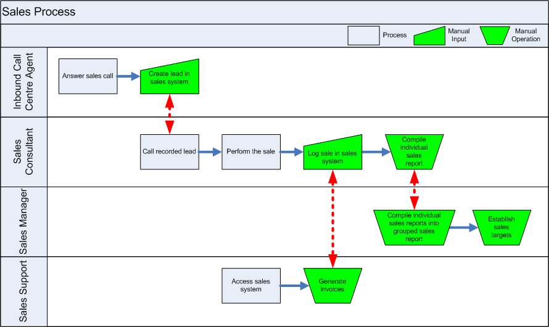
Common workflow systems will govern and control the flow of deliverables between role players to ensure that the correct deliverable reaches the correct role player and that the chain of operations is not broken.
The workflow engine does not help role players to do their job, nor does it verify the quality of their outputs. Workflow will not prevent mistakes caused by incorrect information being supplied or recorded, it merely prompts individuals when an item has reached their queue and delivers their outputs to the next link in the chain.

Transparent blue blocks represent workflow’s responsibility in the picture below.

A Performance Support Tool (PST) focuses on the individual and their entire role and guides the individual to ensure that he / she knows what is required of them and can perform the required tasks accurately and produce a high level of quality. Touch points can be built into the PST which will ensure that the individual delivers his / her outputs to the correct individuals and ensure that the work flows correctly.
Following a PST ensures consistent work quality and accuracy which creates efficiency in the organisation. Individuals know what to expect from deliverables because everyone is following a governed, guided process of work using the PST.

Transparent orange blocks represent a PST’s impact areas in the picture below.

