Creating a storyboard 'breadcrumb trail '

What is a breadcrumb trail?
If this recalls Hansel and Gretal dropping breadcrumbs in the forest, so that they can find their way home, you're close! This story was the origin of the breadcrumb trail concept.

- A breadcrumb trail is an online navigational tool that tells the learner where the current page is in relation to the rest of the content.
- It is used in HTML storyboarding.

Benefits of a breadcrumb trail
- Indicates where you are in the content
- Indicates the content trail you followed to get there
- Allows learner (through a link) to quickly return to a landing (navigation) page

So, what does it look like on screen and how does it work?
Look through the following screen shots and related comments to answer these questions.
- Not every screen has a breadcrumb trail, e.g. a landing page:
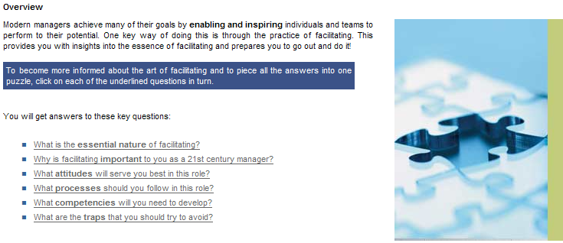
- When the learner clicks on a drill-down link on a landing page, a breadcrumb trail appears at the top of the screen, indicating the location of the content within the module. In this example, the learner was on the 'Overview' screen, and is now reading about the 'Essential nature':

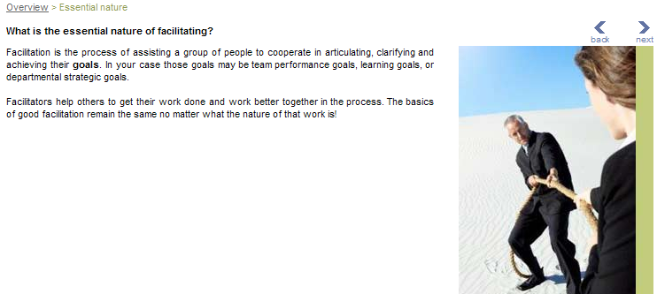

- If the drill-down is more than one page, the pages that follow will have the same breadcrumb trial:

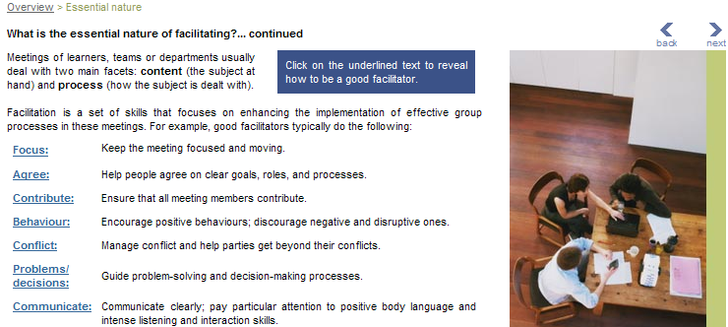

- To return to the landing page, the learner can either click on the next button or on the underlined text in the breadcrumb trail:

- Back on the landing page, the learner can click on a different drill-down link. The new page will show an updated breadcrumb trail with the current location:

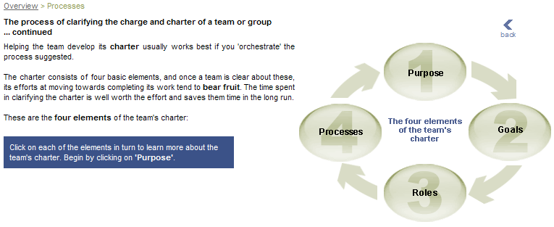

- If this page has a further drill-down (e.g. click on the diagram components to access further information), the new pages shows a longer breadcrumb trail:

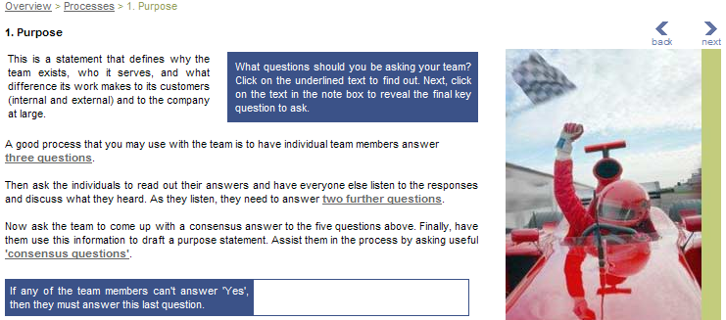
Breadcrumb trail on the storyboard
A learning designer is responsible to add the breadcrumb trail when creating a storyboard (if you have not done this so far, please begin to do so). Select one or two words that summarise where in the module hierarchy the content belongs, e.g. Overview | Processes:

